

OGAM
Harmonization Service Architecture

Contents

1 Introduction 3
2 Interface description 4
2.1 HarmonizationServlet 4
2.1.1 HarmonizeData 4
3 Harmonization Process 4
3.1 Data copy 4
3.2 Data pre-calculation 4

Introduction

The harmonization service is used to copy the data from one schema (the RAW_DATA schema) to another (the HARMONIZED_DATA schema).

During this operation it is foreseen (not implemented yet) to harmonized the data from all countries using some rules defined by some “bridges” and the available metadata.

The harmonization process is also used to pre-calculate some data in order to accelerate the further operations on the data.

The harmonization process is launch manually once the data have been uploaded and validated by the countries.

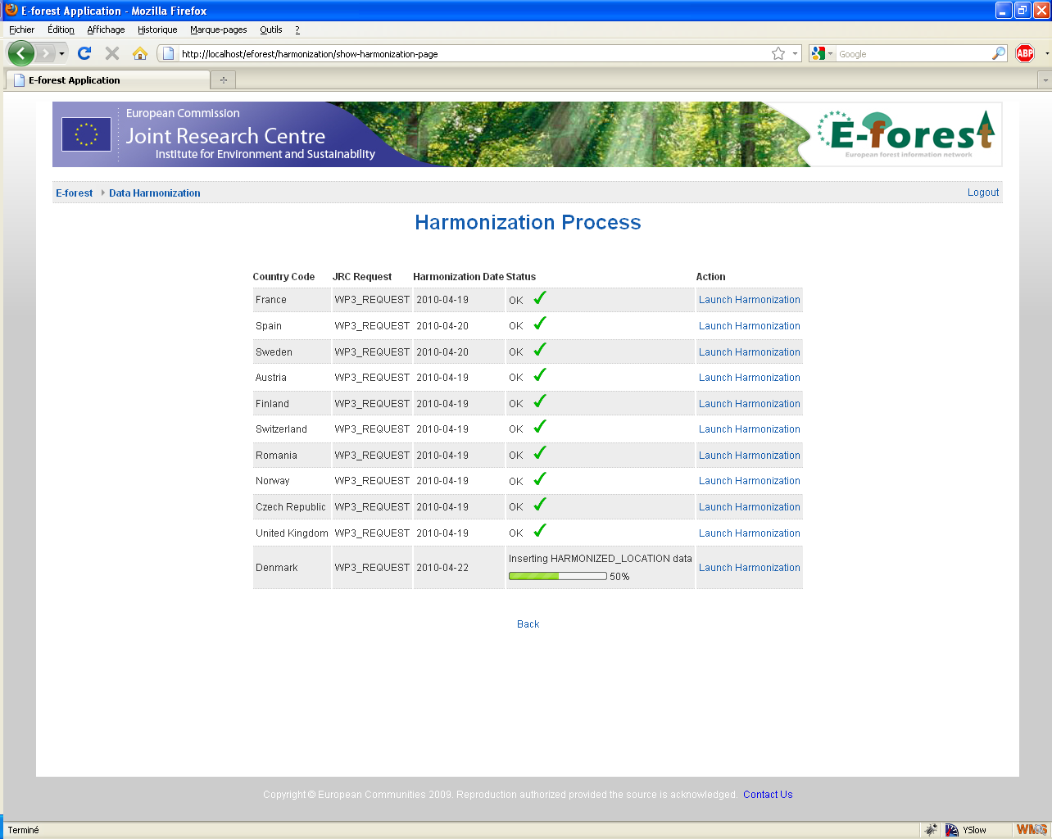

Interface description

HarmonizationServlet

This servlet is used to transfer data from the raw database to the harmonized database.

HarmonizeData

This action launch the harmonization process.

The mandatory parameters are:
- DATASET_ID
- PROVIDER_ID

Harmonization Process

Data copy

The harmonization process is based on the metadata, the main entry point in the code is the “HarmonizationService” java class.

During harmonisation, data is copied from the raw database tables to the harmonized database tables according to the defined mapping.

For a given dataset and a country code, we search for the source raw data fields concerned and the destination harmonized fields (by using the mapping table).

Once the mapping is build, we build a SQL request to read the data from the source tables and we iterate thru the result to insert the data in the destination tables. This process takes into account the hierarchy of the tables to insert the data in the right order and to respect the integrity constraints.

In order to avoid some memory and performance problems, the data is read and written by batches of 5000 lines

Data pre-calculation

At the end of the copy of the data, we can also launch some procedures like:

- Precalculation of the different cell identifiers for each raw data location (we fill the nuts_0, cell_id_50 and cell_id_100 columns of the raw_data location table).
- Precalculation of some cluster weights
- Update of the plot location to blur them (we align the plot location of the harmonized database to the nearest 1x1 km grid cell).

